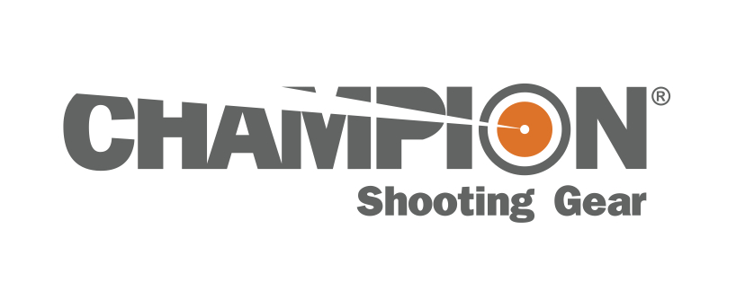
Contact: JJ Reich
Public Relations Specialist
763-323-3862
FOR IMMEDIATE RELEASE E-mail: pressroom@atk.com

Champion® Pivot Traverse Bipod Wins Field & Stream Best of the Best Award

Champion® Pivot Traverse Bipods have earned a Field & Stream 2013 Best of the Best Award in the gear category. The Pivot Traverse Bipod system was chosen because its innovative design enables users to rotate back and forth on a horizontal plane, allowing easy tracking of moving game and faster switching between targets.

ANOKA, Minn. – July 19, 2013 – Champion® Shooting Gear is proud to announce its innovative Pivot Traverse Bipod has won a coveted Field & Stream 2013 Best of the Best Award. The Pivot Traverse Bipod enables shooters to pivot back and forth on a horizontal plane to hold steady on moving game and quickly switch targets. It also offers a rapid-adjust lever lock to quickly cement the rifle into a rock-solid position.

“Our staff spent the better part of the past year finding and testing the gear that will make readers’ time in the woods more productive and more fun,” said Slaton White, Deputy Editor of Field & Stream. “The Best of the Best is the highest honor Field & Stream bestows on gear and the winning products are the best of the year.”

“Over the years, I’ve shot off a variety of shooting sticks—some good, some truly bad,” White said. “Here’s a better way. This adjustable bipod enables you to horizontally track a moving animal without having to shift your shooting position. It can also cant to move the rifle off the vertical, if the terrain so requires.”

“Whether it’s staying on moving game, switching between animals or engaging multiple targets at the range, the Pivot Traverse Bipod delivers smooth rotation and a steady hold,” said Champion’s Product Manager Eric Miller. “Its innovative traversing technology enables a shooter to horizontally track back and forth, which expands the field of fire and produces increased shooting options—all without having to reposition the rifle. Plus, the rapid-adjust lever lock lets shooters go from a fluid motion to rock steady lock-down in seconds.”

Versatile and Dependable
The Champion Pivot Traverse Bipod delivers smooth rotation thanks to an ingenious traversing design. It also features an adjustable canting action that allows level shooting on uneven terrain. Other features include a rapid-adjust lever lock, spring-return telescoping legs, and a durable all-metal construction with rugged tubular legs. The Bipod comes in four sizes and easily attaches to the sling swivel stud of most firearms.

Part No. Description MSRP
40635 Pivot Traverse Bipod—6”-9” $67.25
40636 Pivot Traverse Bipod—9”-13” $67.46
40637 Pivot Traverse Bipod—13.5”-23” $68.49
40638 Pivot Traverse Bipod—14.5”-29” $73.49

See the complete lineup of Champion products at www.championtarget.com. Watch a video of this Bipod in action at http://www.championtarget.com/resources/videos.aspx.

###

